1. Azure hierarchy
1. Management Groups (The Top-Level)
- What it is: This is the highest level of Azure’s structure. It's like a parent folder that helps organize your entire Azure environment.
- Purpose: It helps you manage and organize multiple subscriptions across your organization. You can group subscriptions based on departments, teams, or projects.
- Example: Imagine a company with multiple divisions, like Finance, IT, and Marketing. You could have separate management groups for each of these divisions.
2. Subscriptions (Middle Layer)
- What it is: Underneath management groups, you have subscriptions. A subscription is like a container for Azure resources, where you’ll define limits on resources and billing.
- Purpose: It helps with organizing resources, managing access, and billing. You can have multiple subscriptions for different projects or teams. Each subscription has its own resource limits and billing.
- Example: If your company has different projects, like a website and an app, you could create separate subscriptions for them. One for the website, one for the app.
3. Resource Groups (Sub-Containers)
- What it is: Inside each subscription, you can have resource groups. These are containers that hold related resources.
- Purpose: They help organize resources based on their lifecycle and permissions. All the resources in a group are usually related to the same project or service.
- Example: If you're building a web app, you might have a resource group called "rg-ohg365-dev" where you store everything related to the app, such as databases, storage accounts, and virtual machines.
4. Resources (The Actual Items)
- What it is: These are the individual services or products that you create in Azure, like virtual machines (VMs), storage accounts, databases, or networks.
- Purpose: This is where the actual work happens! Resources are the building blocks of your cloud environment.
- Example: In your "rg-ohg365-dev" resource group, you could have resources like a VM to run your website, a database to store your data, and a storage account for storing files.

Management Groups: High-level containers for organizing multiple subscriptions.
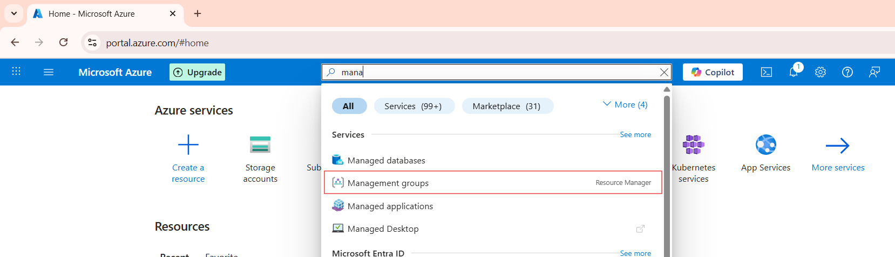

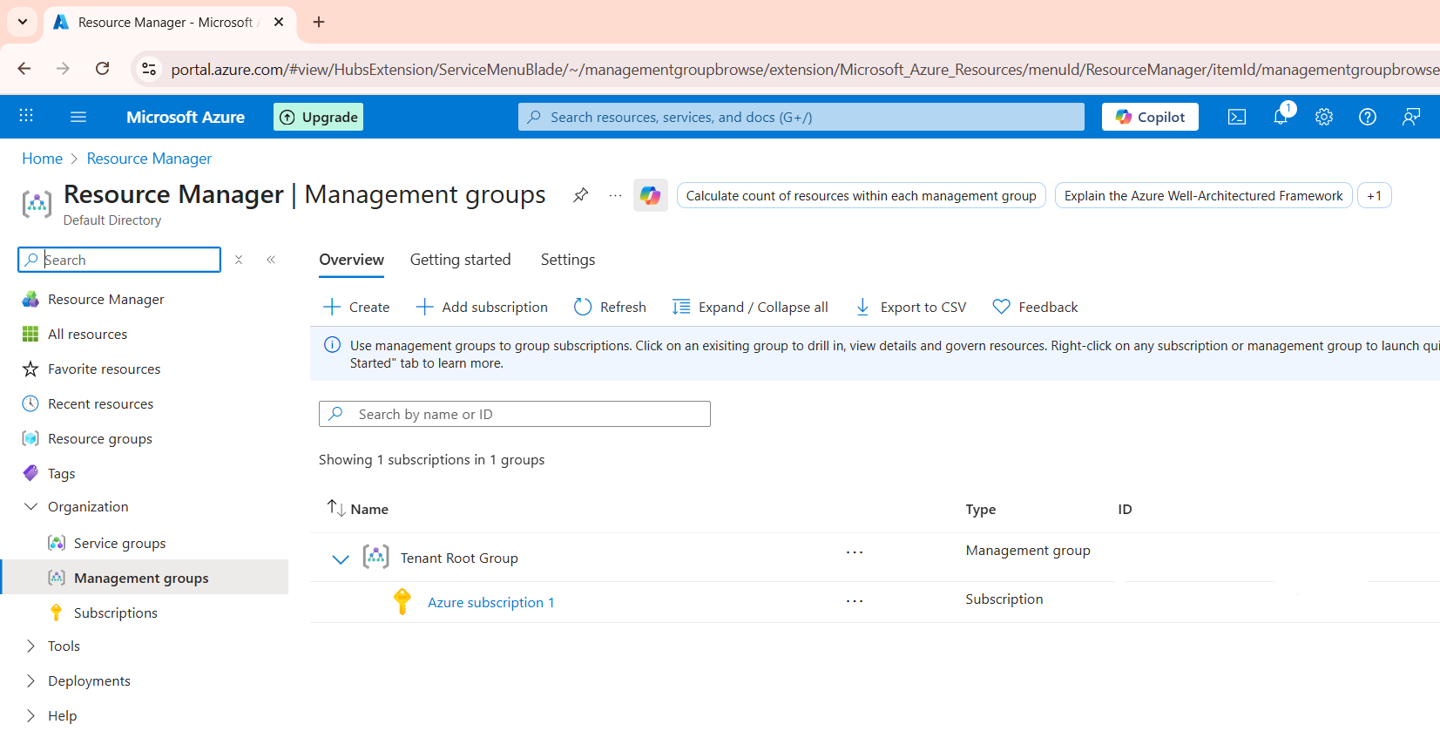
Subscriptions: They hold resources and manage access to resources.
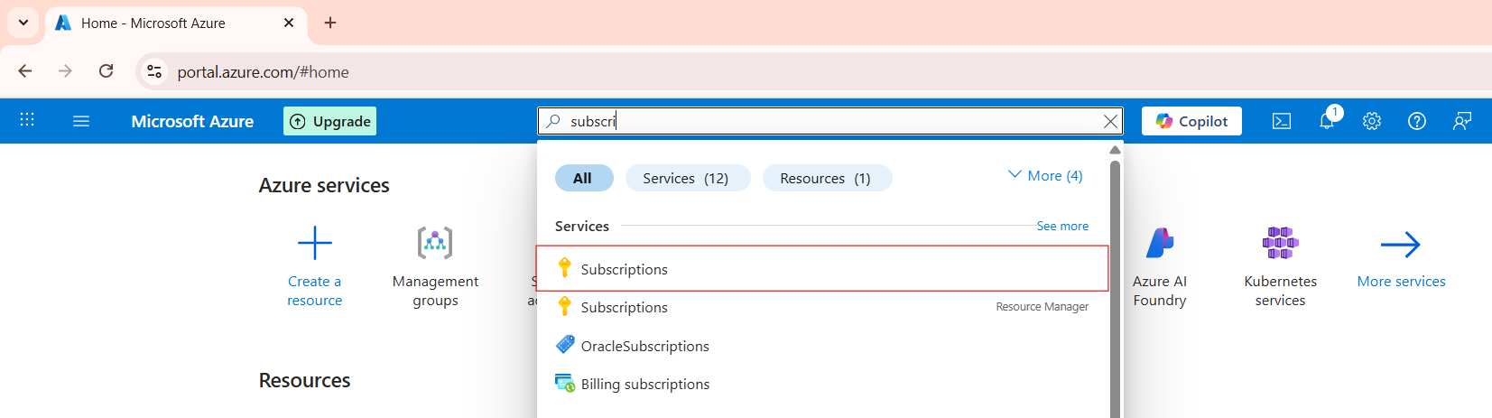

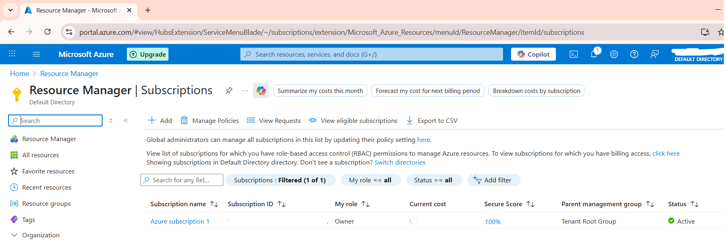

Resource Groups: Containers inside subscriptions to organize and manage resources by project or lifecycle.
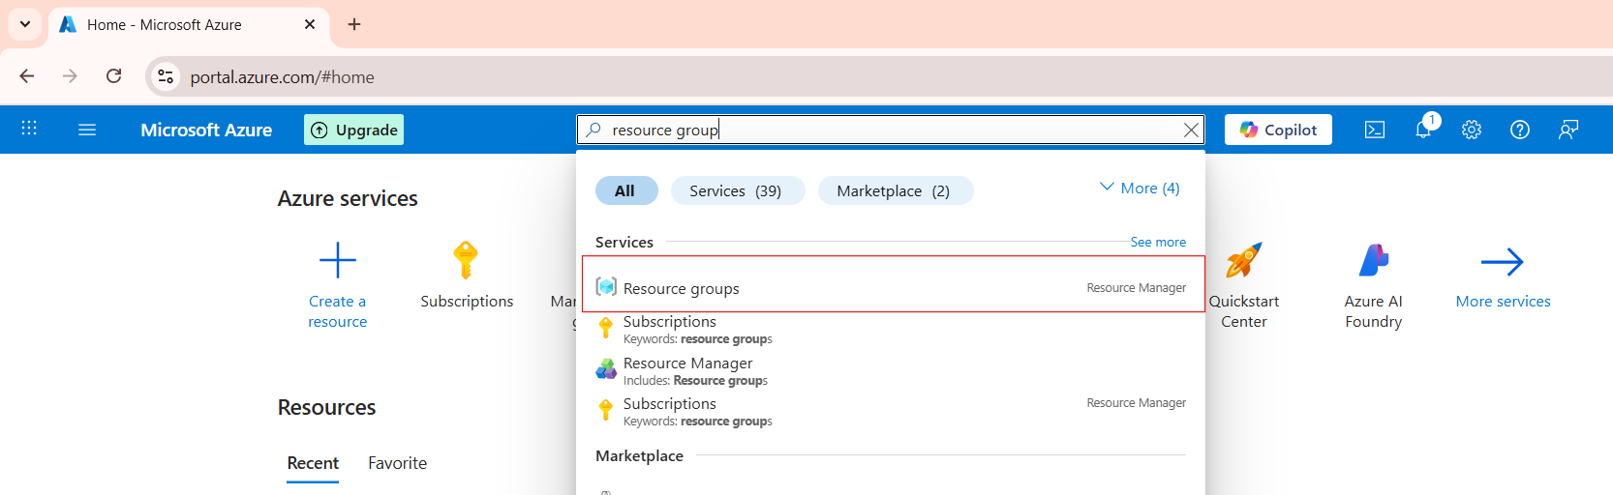

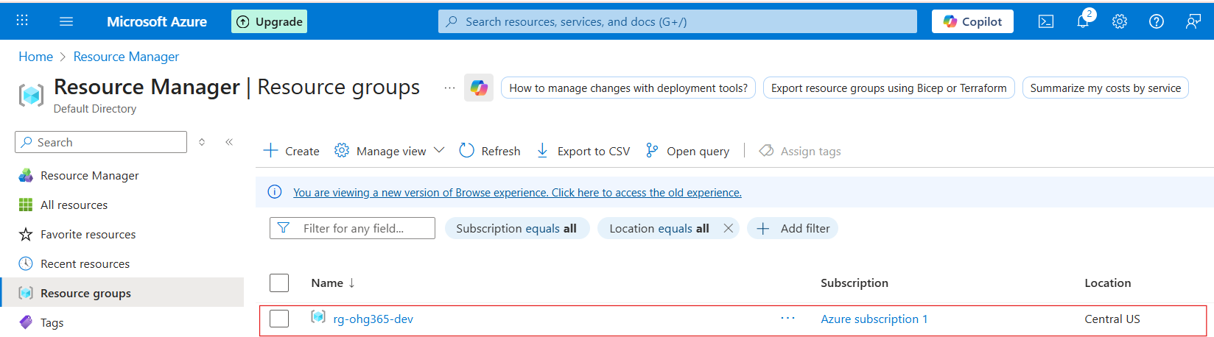

Resources: The actual services you use in Azure.

